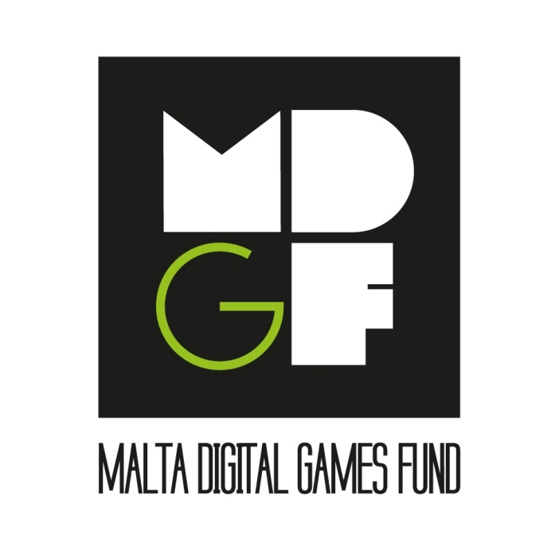

OFFICIAL APPLICATION FORM

CALL FOR PROPOSALS 2017

www.artscouncilmalta.org
fundinfo@artscouncilmalta.org

CONTENTS

INSTRUCTIONS

Section 1: APPLICANT’S DETAILS
Section 2: PROJECT DETAILS
Section 3: OWNERSHIP OF RIGHTS
Section 4: APPLICANT’S DECLARATION
Section 5: WHAT TO SUBMIT

INSTRUCTIONS

- Refer to the Malta Digital Games Fund Guidelines for Applicants for guidance.

- Applications must reach the following address not later than 12.00 noon 6th June 2017:

Malta Digital Games Fund
Arts Council Malta
16, Casa Scaglia
Triq Mikiel Anton Vassalli
Valletta

- Applications that do not include all the requested material as specified in the guidelines will be considered ineligible.

- The applicant is required to fill in the official Application Form (Section 1 to Section 4) and to submit it either in electronic format, or in hard copy and a digital copy (on USB or CD).

- The electronic and digital copies of the application should contain three separate folders, named and containing the relevant information as follows:
(a) Completed application form (Section 1 to Section 4)
(b) Mandatory documentation (as listed in Section 5)
(c) Additional documentation (as listed in Section 5).

- The project proposal will be evaluated on the basis of the submitted documentation in terms of the award criteria by an independent expert team as outlined in the Guidelines for Applicants.

IMPORTANT NOTE

Arts Council Malta will use the information submitted to process applications and awards in line with its published guidelines and will retain confidentiality in compliance with all applicable Data Protection legislation.

If, at any point during the evaluation or implementation process, sound evidence is discovered that contradicts the Applicant’s Declaration below, Arts Council Malta shall disqualify the application as ineligible and, if a project has been approved for funding, shall demand full reimbursement, with interest, of any payments already issued to the applicant.

SECTION 1
APPLICANT’S DETAILS

1. Applicant’s Information
In this Application Form, where reference is made to ‘entity’ this is to be taken to mean any legally-recognised eligible status (limited liability company, partnership or cooperative) that the applicant may have, or in the case of a group of individuals, the name of the person will be taking legal responsibility of the project.

  - Name of applicant entity (if applicable)

  - Name of legally authorised representative of Entity and ID Card number

1.3 Contact Person’s name
1.4 Contact address
1.5 Contact details | Business tel:  Mobile:  Website (if available):  Email:
1.6 VAT registration number (if applicable)

2. Company Information (not applicable to Groups of Individuals)
See Section 5e of Guidelines for details on Applicant Eligibility.
2.1 Trading name of company (if different from above)
2.2 Full legal name of company (if different from above)
2.3 State the legal status (company ltd., partnership, etc.) and the principal function/purpose of your company

2.4 Date of company registration and registration number

2.5 Are you a branch or a subsidiary of a larger organisation?  (If yes, select and give the full name of the company) | Branch Yes □  No □  Subsidiary Yes □  No □  Full Name of company:
2.6 Name of Chief Executive/Managing Director of Applicant Company

3. Quality, Experience and Qualification of Applicant Entity
3.1 Entity Profile
Provide in not more than 200 words details on the Entity’s track record and expertise in relation to digital games production or to pertinent areas of specialisation.

4. Previous digital games produced by the applicant company / employees / shareholders / group or individual members of the group:

Title of the work | Producer | Type of game | Platform | No. of units sold/ distributed | Publisher

SECTION 2

PROJECT DETAILS

1. Title of Project

2. Type of Game

3. Proposed Team
Please specify name and role of the team members (project lead, creative lead, programming lead, art director, project manager, etc.)
Name | Role | Nationality & Residency | ID Card No / Passport No | Previous Work/Title

4. Describe the Game

4.1 SYNOPSIS
Give a brief description of the project (150 words)

4.2 Describe the game
Provide details on game-play, content, graphics, interface, and design aspects. Detailed storyboarding, visuals and illustrations such as concept art or simulated screen-shots must be included at the end of the document. (Max 800 words)

5. Delivery platform/s:

6. Aims and Objectives
Describe your main objectives and unique selling proposition which distinguish your project from other games. Explain how this concept relates to the target audience and how it will engage the audience (Around 300 words)

7. Creativity and Innovation
Describe the creative and innovative elements of your proposed project

8. Marketing and Distribution
Please describe how you intend to distribute and market the project.

9. Time Plan
9.1 Total duration of development of project:

9.2 Project Time Line (Please provide a detailed outline of the month/date/task, start/end dates of each phase, type of work and estimated hours).

10. Budget Details

10.1 Total project budget of the proposed project (eligible and ineligible costs) | €
10.2 Total project budget of costs eligible under MDGF (refer to Section 6 (c, d) of the Guidelines). | €
10.3 Total grant requested from the Malta Digital Games Fund:  (Project grant awarded may amount to not more than 75% of the eligible budget) | €

Applicants are required to provide a detailed breakdown of the budget using Appendix 1 (Budget Template) as part of this application form. Both sheets ‘Phase 1’ and ‘Phase 2’ are to be submitted.

11. Intended Sources of Finance for the entire Project
Please state in the table below the sources of finance envisaged to cover the total project budget, together with their status. In the case of confirmed financing, kindly attach proof with annexes.
Source of Finance  (e.g. MDGF support, company’s own investment, sponsors, co-production agreements, Crowdfunding etc.) | Name of Financial Partner | Date of Contract or Letter of Intent | Amount  € | Status  (confirmed / to be confirmed) | %

SECTION 3

OWNERSHIP OF RIGHTS

I hereby declare that the applicant entity holds the majority of the rights relating to the project for which support is being sought.

1. The project is (tick as appropriate):
An original work □ | An adaptation □  In this case, please provide agreements for the existing work as well as the adaptation as listed in annexes.

SECTION 4

APPLICANT DECLARATION

Kindly submit a print out of this document

Name of Applicant Entity: …………..………………………………………….
Contact Person: …………..………………………………………….
Email: …………..………………………………………….
Project Title: …………..………………………………………….

I, the undersigned,……….…….………………….. I.D. Card number ………………………………… declare that I am the authorised signatory for the applicant entity and guarantee that:

- The information contained in this Application Form and its annexed documents is complete and correct and in accordance with the terms defined in the Guidelines for this call for proposals (2016).

- The applicant has all the Intellectual Property rights to the project.

- The applicant has the Commercial Rights to this project.

- The applicant is aware of its State Aid position on De Minimis funding and should the project be successful will still be eligible to receive funds for both Phases of the project.

- The proposed project does not infringe the rights of a third party.

- The proposed project has not already been finalised.

- The proposed project does not promote violence, racism and/or pornographic content or in any way violate the Maltese Constitution.

- In case of selection, the applicant entity accepts that its name and address, the type of financial support, the amount awarded and the rate of funding will be published by the Arts Council Malta.

Signature: ……………….............…..... Date: ……….……………….
Applicant or entity representative

Full Name of Signatory:..............................................................................................

Designation of signatory in applicant entity: ………………………………….

SECTION 5

WHAT TO SUBMIT

- APPLICATION FORM

- Printed and Digital Copy of filled-in application (Section 1-4).
- Printed and Digital Copy of filled in Appendix 1 (Budget Template), Phase 1 and Phase 2
- A printed copy of the Declaration Form (Section 4).

(b) MANDATORY DOCUMENTATION

- Detailed storyboarding
- Links to and/or visual material of proposed project e.g. digital renditions, drawings etc.
- Evidence of ownership of rights for proposed project or contract of acquisition / transfer of rights.
- Entity profile and CVs of key persons to be involved in proposed project.

(c) ADDITONAL DOCUMENTATION (if available)

- Links to and/or visuals of previous work, where applicable.
- Letter(s) of intent from financing partners.
- Letter(s) of interest of co-development, co-production, pre-sale/distribution and/or other agreement(s).
- Acceptance letter/receipt from a Crowdfunding platform
- Proof of confirmed financing from other sources.

